### **Day 13**

### **Multi-Branch Project**

#### **Project Deliverables**

1. **Git Repository:**
   * Local Git repository initialized.
   * Branches: development, staging, and master.
   * Repository pushed to remote Git server (e.g., GitHub, GitLab, Bitbucket).

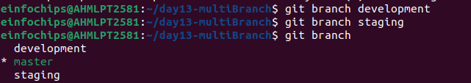.

I have created two branch for development and staging

1. **Java Project:**
   * Simple Java project created (HelloWorld application)

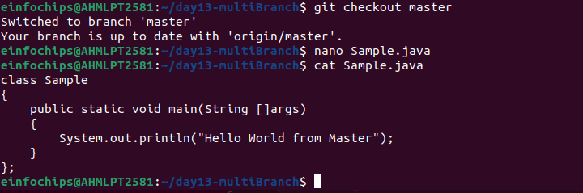.

In master Branch I created a Sample.java file with simple print statement “Hello world from Master”

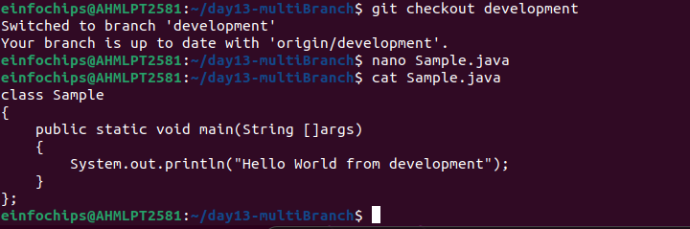.

In development Branch I created a Sample.java file with simple print statement “Hello world from development”

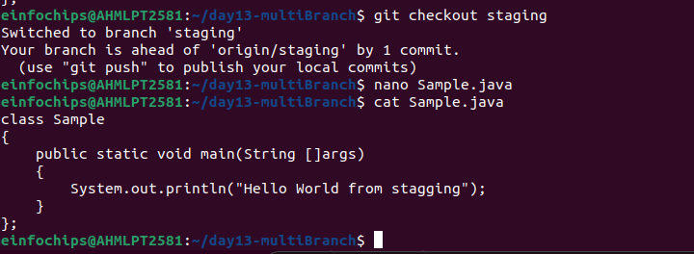.

In staging Branch I created a Sample.java file with simple print statement “Hello world from staging”

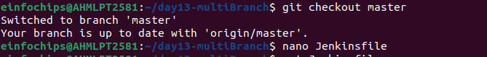.

created Jenkinsfile in master branch

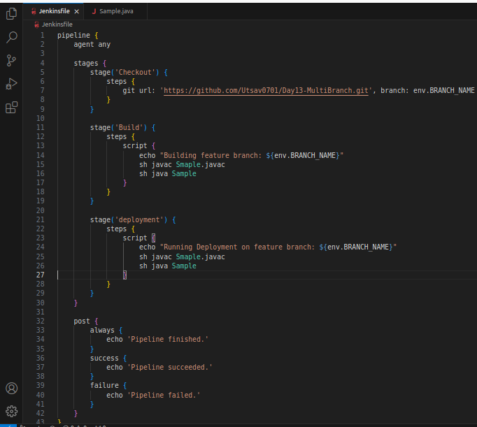.

1. **Jenkins Setup:**
   * Multi-branch pipeline job configured in Jenkins.
   * Jenkinsfile defining build and deployment steps.
   * Environment variables managed using Jenkins environment variable settings.

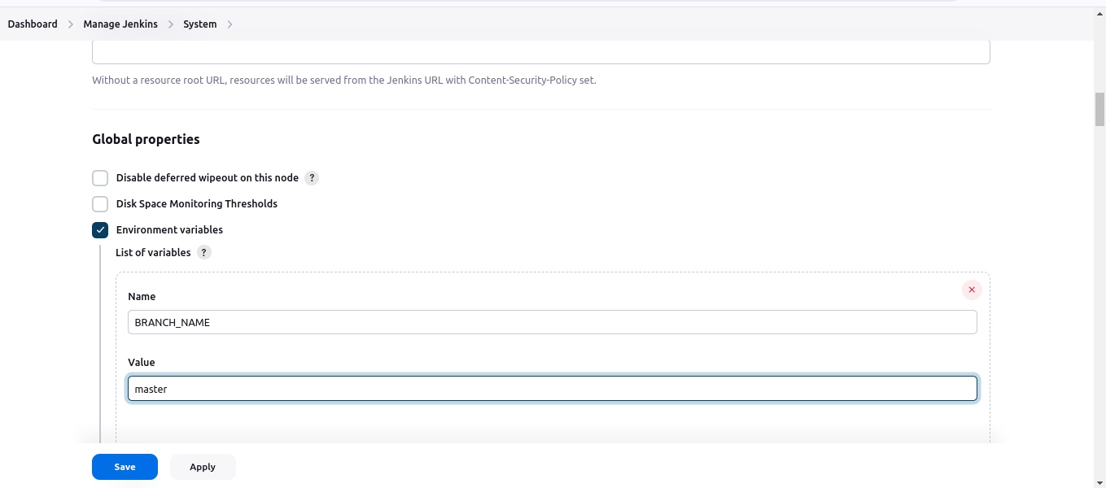.

In jenkins dashboard i added an Environment Variable with name BRANCH_NAME with value master/development/staging.

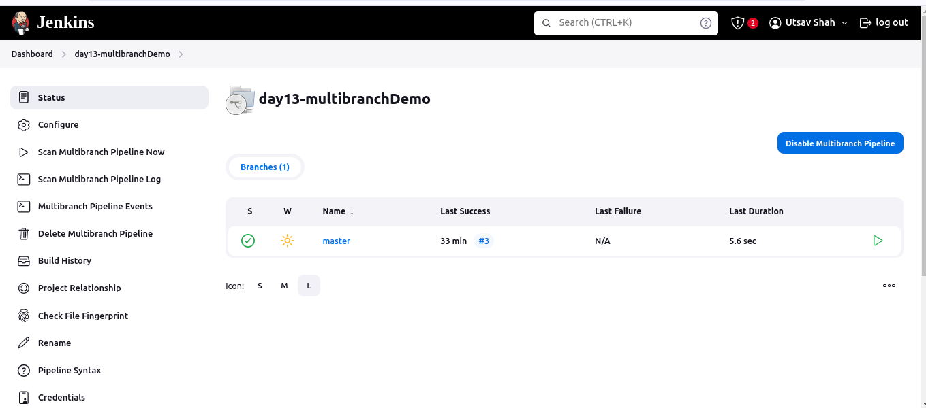.

Created a multibranch pipeline project for this project.

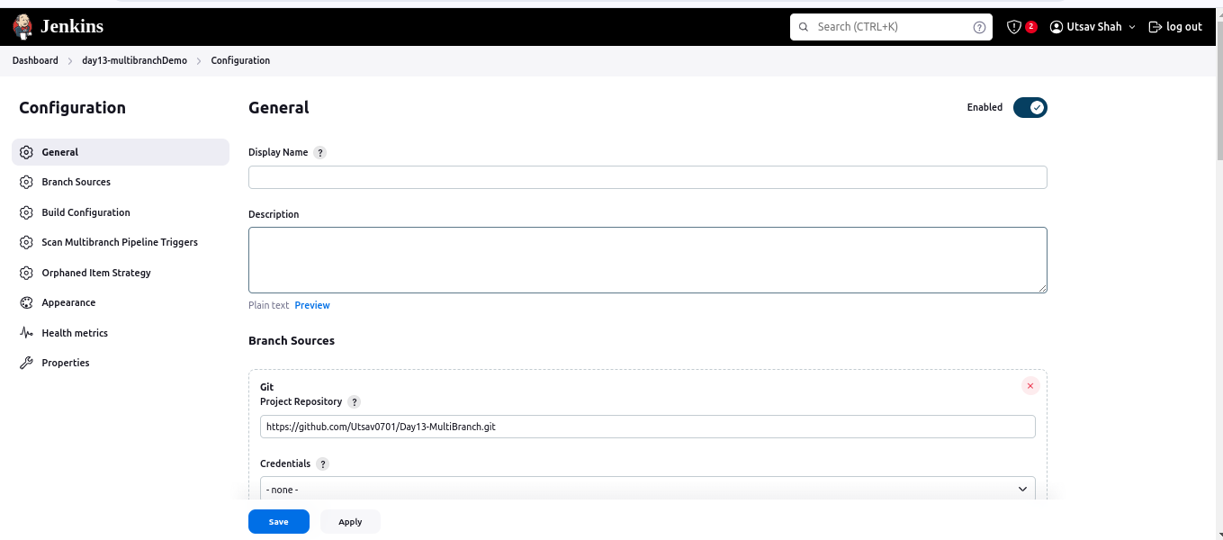 .

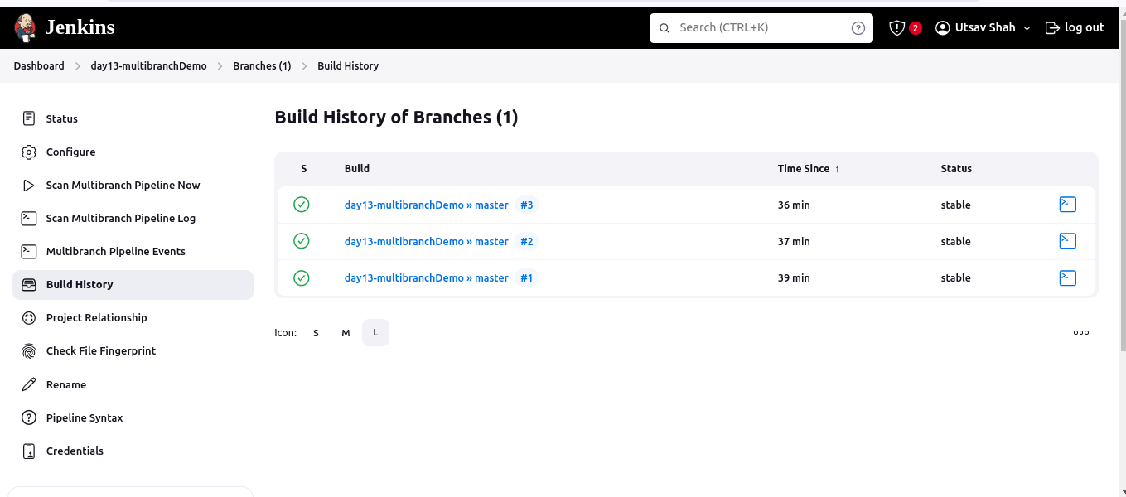.

bulild that file for 3 times with different environment variable

1. master

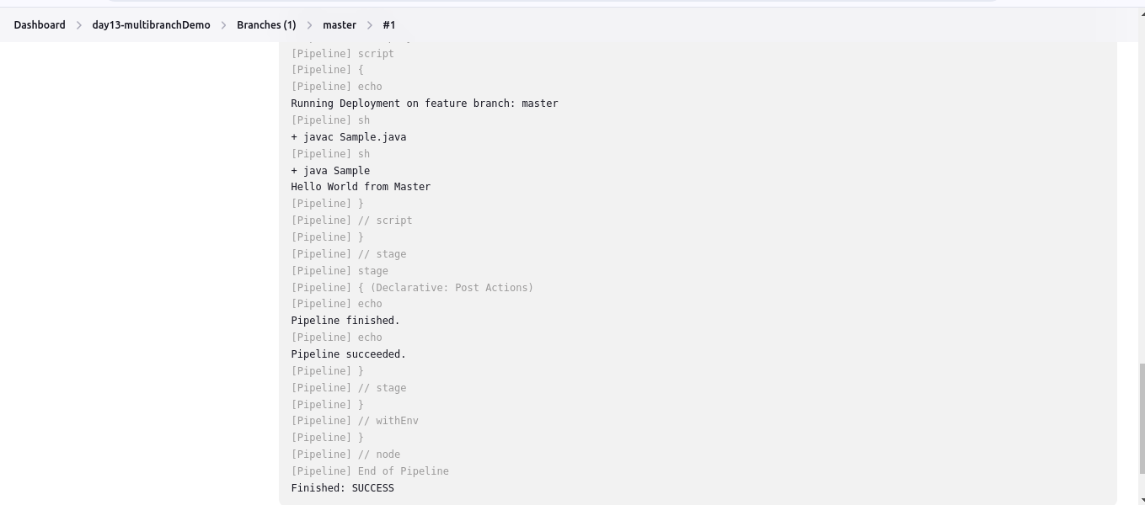

2. deployment

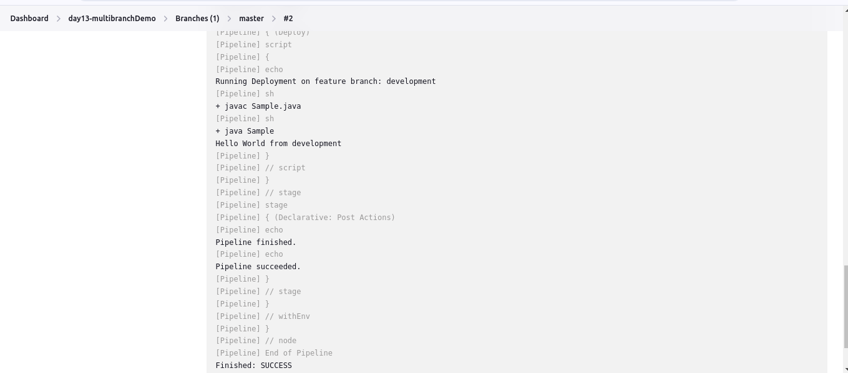.

3. staging



